**­­­­­Xtag Architecture Specification**

**Date:** 12/6/18

**Revision:** 1.16

**Authors:** Justin Reina, Tomm Aldridge

**Organization:** Ergsense LLC

**Summary:**

This document describes a proof-of-concept (‘PoC’) pump-monitoring device for Xylem Applied Water Systems which provides motor monitoring and reporting. This is Xylem’s first efforts into the pump monitoring market and the device will follow a provided commercial specification. Support for extension to additional Xylem products1 and subsequent ISO models is included as well.

**Need:**

Existing ISO pump systems have need for monitoring solutions for their full lifecycle, with a customer base ready for adoption. Xylem identifies this with ‘Must Have’ qualification and sets forward here to a­­chieve this.

**Selected Device:**

Xtag, as provided by ergsense LLC in cooperation with Xylem technical and business personnel, is the headless monitoring tag solution for Xylem motor assets of a new generation of pumping products.

**Notice:**

This document is a recommendation for Xylem and pending review and approval for completion.

**Table of Contents**

1. Introduction 3

1.1. Customer 3

1.2. Opportunity 3

1.3. Solution 3

1.4. Feature Levels 4

1.5. Objectives 4

1.6. Value Statement 4

1.7. Operating Environment 5

1.8. Needs 5

1.9. Use Cases 5

1.10. Applications & Users 5

1.11. Constraints 5

2. Device Description 6

2.1. Functions 6

2.2. Theory of Operation 7

2.3. Module Description 7

2.4. Sensing 8

2.5. Reporting 9

2.6. Communications 9

2.7. Power Management 10

2.8. Selection of Technologies 10

3. Proof of Concept 12

3.1. Objective 12

3.2. Xtag 12

3.3. Goals 12

3.5. Xtag-B2 13

3.6. Xtag-M 13

3.7. Xtag-Ext 13

3.8. Level Description 14

3.9. Design Modularization 14

3.10. System Integration 14

3.11. Design Flow 14

3.12. Device Validation 14

3.13. Deliverables 14

4. Device Design 15

6.1. Hardware Design Procedure 15

6.2. POC Components 15

6.3. Technology Selection 15

6.4. Design Selection Opens 15

5. Next Steps 15

Appendix A – Processor Selection 16

Definitions 17

Acronyms 17

References 17

Notes 18

# Introduction

## Customer

Xylem Applied Water Systems is targeting a low-cost, online asset monitoring tag for pumping solutions.

## Opportunity

Xylem supplies thousands of offline assets, with the opportunity to provide online services as well. The market is present and ready now for connection of their assets, but apprehensive due to costs and risks. This technology will provide pump monitoring and related services to be offered.

Integrated monitoring solutions give desired value within the pumping market, providing full-system monitoring & reporting with easy installation & data visualization. Xtag provides this in combination with xCloud, connected over a secure extranet. With this solution for online assets in-hand, needed services are delivered to existing and new customers resulting in a larger revenue model being established for Xylem.

## Solution

The Xtag solution provides pump unit monitoring & reporting, with advice for operations and notification on status or warning providing new value to the customer. Figure 1 below illustrates the Xtag concept, as applied to a Xylem ISO Pump.

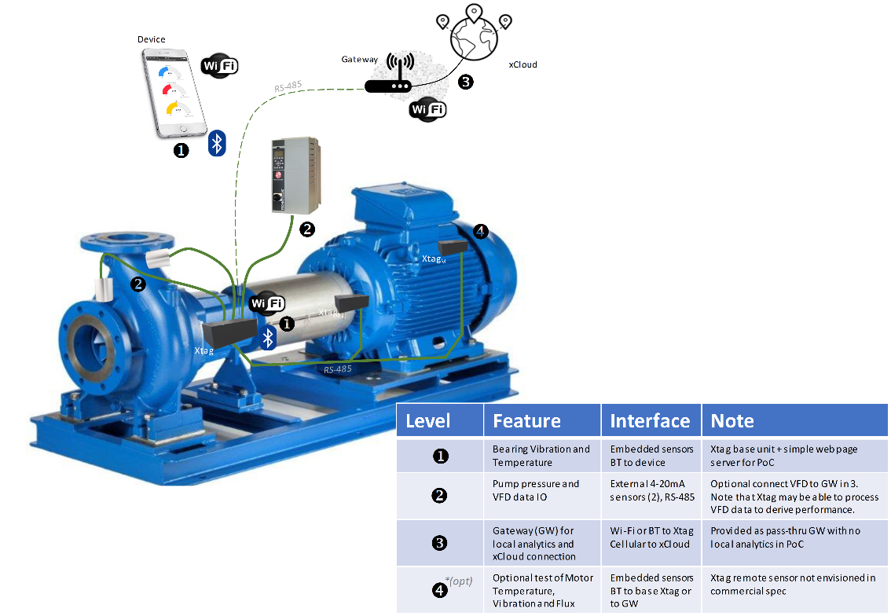

**Figure 1:** Xtag Solution Diagram

Xtag monitors multiple components of the pump installation which includes the pump, its motor and connection bearing frame. Parameters are sensed and recorded, including point temperatures, motion, vibration and pump pressure values, stored with report on request.

Xtag is part of a larger tracking system that collects pump status and information using the xCloud, connected over a secure extranet connected through a gateway. A clean, real-time14 interface is provided for asset statistics and report over multiple interfaces which include web, mobile & local at the first stages of the product roadmap.



## Feature Levels

Features will be provided at the following levels:



**Table 1:** Feature Deliverable Levels

Xtag hardware will remain equivalent for levels 2 and 3. For all Xtag levels electrical will be similar, with changes in mechanical and delivery present.



## Objectives

This work enables delineation and opportunity in the asset-tracking market for Xylem, who is in the ideation stage at present and looking to begin work on this opportunity. The Xtag solution achieves this, presenting the solution and its data in a format expected by the audience, allowing multiple smart endpoint connections to Xylem xCloud Analytics system with low difficulty and cost.

Current asset tracking solutions are slow and take effort, Xtag sets to changes this. Changes to solution are delivered at first, building towards a new model of asset tracking that in culmination wins the market. Xylem takes the lead in these efforts, bringing calmness and excitement to the customer with the Xtag solution, instigating an excitement and curiosity for what’s next.

## Value Statement

Easy to use asset intelligence with instant access, the Xtag enables complete observation and immediate access to pumping solutions, with automated alarm and notification for safety and time efficiency.

Careful design enables ease of installation and as described previously full system monitoring. These features then create early problem detection with recommendations and assistance for resolution as well.

## Operating Environment

* Storage (-40° to 100° C)
* Operating (0° to 85° C)
* Power (Wall, USB, Battery)
* Rel Humidity (98% typ)
* Enclosure (IP652)
* Safety ([UL/IEC 60950](https://www.google.com/url?sa=t&rct=j&q=&esrc=s&source=web&cd=1&cad=rja&uact=8&ved=2ahUKEwj59Y6zx_TcAhVOyYMKHTNJBOIQFjAAegQIBhAC&url=https%3A%2F%2Fwebstore.iec.ch%2Fpreview%2Finfo_iec60950-1%257Bed2.0%257Den_d.pdf&usg=AOvVaw1eQtyMDT6l_QkQcpn6Y4iR), UL 508)
* RF Compliance (FCC/CE)

## Needs

* Meet commercial specification ([1])
* Meet specification levels 1, 2 & 3
* Ready to manufacture
* Enables use as a testbed for value added technologies such as embedded sensors, inferencing and motor health

## Use Cases

1. Technology PoC to validate and inform

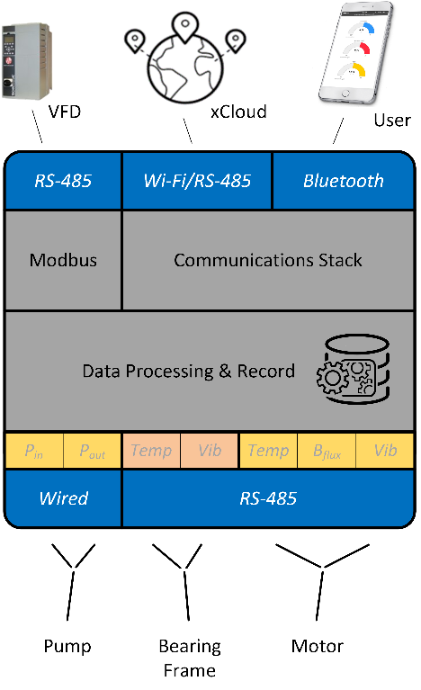

**Figure 2:** Xtag Communications

1. Framework for future products & design

## Applications & Users

1. Lab & controlled installations for testing & validation by engineering
2. Field installation for product validation by trained service personnel
3. Pre-production deployment in ‘friendly’ non-Xylem sites for VoC feedback by non-Xylem personnel

Note (a) is in scope of current project while (b) & (c) will require a new project to begin. All are necessary to conclude a successful product development cycle.

## Constraints

1. Commercialization Specification Levels 1, 2 & 3 must be met
2. Mechanical form factor compliance with form factor and external connectors
3. $50 Target In-the Door BoM10 for Level 1 PoC
4. Full operation at 85° C
5. Global market coverage

# Device Description

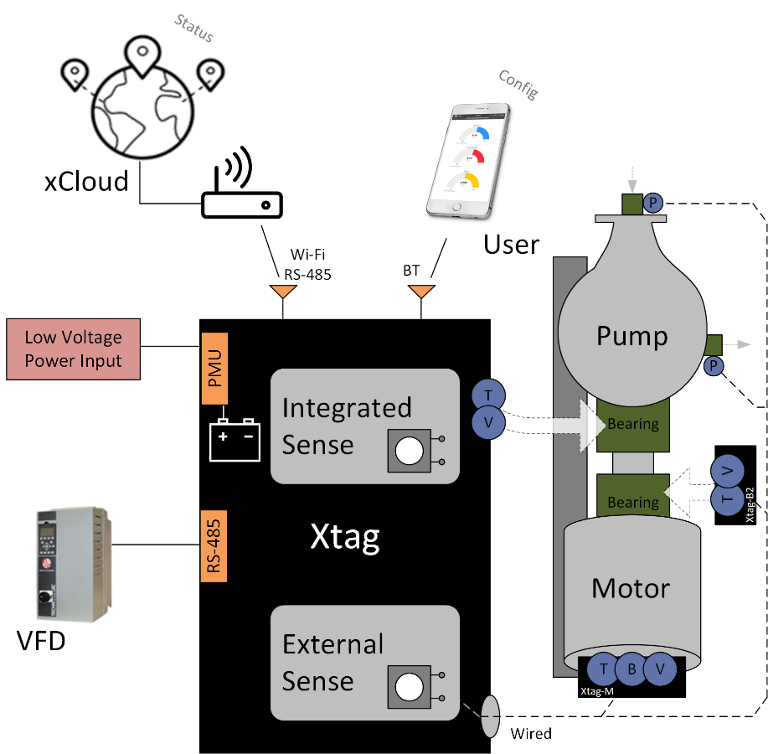

**Figure 3:** Xtag Hardware Diagram



**Table 2:** Optional Motor-Sense Deliverable Levels



**Table 3:** System-Sense Deliverable Levels

## Functions

Xtag shall support the following features across different levels of product:



**Table 4:** Xtag Feature Specification

## Theory of Operation

What is Xtag?

Xtag is an edge intelligence device intended to provide an integrated sensor management and data communications function for Xylem ISO pumps systems.

What does it deliver?

Xtag delivers the following functionality:

* 1. Sensor intake and conditioning for
     1. (2) external pressure sensors via isolated 4-20mA analog ports
     2. (1) internal vibration sensors using MEMs 3-axis accelerometers
     3. (1) internal IR surface thermometer
     4. (1) external thermocouple (Type K) for validation of embedded sensor (c)11

Signal conditioning will consist of both HW and FW components for maximum flexibility and lowest BoM cost.

1. Data averaging and packaging in firmware to reduce data payloads sent to communications to a minimum acceptable size
2. Alarms management to allow Xtag to communicate the state of the data from one or more sensor inputs
3. Data Logging of selected information to local NVM for later transmission (buffering12) and for local recovery in case of communications or other hardware or firmware failure
4. Great analysis and data visualization tools which are easy to use
5. Remote notifications to maintain optimum configuration
6. Communications
7. (RS-485) Input to allow adding VFD data to the sensor data stream in real time
8. (Wi-Fi/RS-485)9 Enable connections to xCloud for sending data and managing the device
9. (Bluetooth) User device access to Xtag data

## Module Description

The Xtag solution features module-based sensor solutions, with naming as follows –

Module Naming Convention

* **Xtag** Primary controller module (also denoted Xtag-B1)
* **Xtag M-Module** Remote ‘motor’ sense module (B, V, T)
* **Xtag B2-Module** Remote ‘second bearing’ sense module (B, V)13
* **Xtag Ext-Module** Ideas module sharing opportunities & ideas for product



**Table 5:** Module Mounting Description

## Sensing

The Xtag will continuously monitor all parameters listed below, providing record and statistics3 on request, fully compliant to [1]. Reverse connection protection is supported for all sensors.

### 2.4.1. Bearing Frame

### Surface Temperature

Temperature will be reported through contact to an embedded-IR temperature sensor, verified with a K-type thermocouple input. Conditioning circuits for the temperature sensor are integral to Xtag-PoC design.

3D Vibration

An LIS3DH 3-axis MEMs accelerometer chip embedded into the remote Xtag design will report on bearing frame vibration.

### 2.4.2. Motor

Method

The motor sensors will be conditioned with an optional Xtag PoC unit mounted directly to the motor, communicating data to the base Xtag or gateway via Bluetooth communications.

### Surface Temperature

Motor surface temperature will be sensed using a non-contact thermometer and verified with a motor mounted K type thermocouple.

3D Vibration

An LIS3DH 3-axis MEMs accelerometer chip will be located at the motor to report motor vibration.

Magnetic Flux

Use of (2) B-series magnetic flux sensors to report on motor rotational rate and direction as well as on motor state (on or off).

Rotational Rate & Direction

Xtag will employ the technique of rotor winding leakage flux sensing to observe phase balance, rotational rate and direction of rotation of the motor. Motor loading and torque will also be reported. This method of using leakage flux to sense direction is Xylem IP.

Relative Load

The analysis of leakage flux amplitude can give a good measure of the load on the motor. When paired with the nameplate data and the expected loading, it can be used to determine the actual operation point of the motor with respect to the pressures and volumes being delivered.

### 2.4.3. Pressure - Inlet & Outlet (Optional)

Pressure (-14 to 300 psi) measured through standard isolated 4-20mA inputs. (2) inputs will be provided in Xtag for connection to external sensors. These are anticipated to be pressure sensors for the PoC but may be any desired sensor meeting the interface specification. The sensors may be integrated into or separate from the pump and may be self-powered or loop-powered from the Xtag.

## Reporting

Local monitoring of pump working condition with report & recommendations for improvement. Device supports external wireless communications with Bluetooth and Wi-Fi and local communications with LED notification.



### Values

All sensor values (Vibration, orientation, location15)

Pump fluids state (Pressure, head)

Pump mechanical state (Hydraulics, vibrations, etc.)

Magnetic Flux of Motors4 (Level, direction)

Pump calculations5 (Head, duty point)

All values timestamped measured with 1% accuracy

### Statistics

Processing and analysis of values (Vibration summary, reports, etc.)

Amazon AWS Support6 (CSV data format)

Interfaces to be provided for statistics access at runtime (See Figure 2)

### Analytics

Great analytics are integrated onboard to Xtag operations and to xCloud support, enabling quick and complete pump system review with recommendations.

### Logs

SD-Card, FLASH (512 MB tgt), external interfaces

All values timestamped with sources known or described

Full description of non-standard device state included (e.g. sensor state, activation, etc.)

Onboard data storage for year of record

### Power Supply

Internal re-chargeable lithium ion battery

External power supply (120 VAC, USB)

*24 VAC external PSU from motor primary (208/230/460/575 3-Phase VAC)

## Communications

Xtag interfaces allow pump monitoring and control through secure remote or local supervision, with full access to data and record.

### Interfaces

The following interfaces are provided for Xtag system integration –

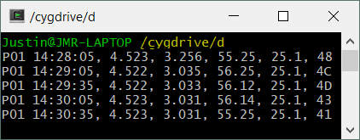

**Figure 4:** Serial output stream example

* LocalL1 (LED)
* Remote L3 (Wi-Fi, Web)
* MobileL2 (BLE, iOS & Android)

### Communication Systems

The following provides complete integration into the target environments with requested user access.

1. Bluetooth

To local mobile device for device setup, config, registration & data review. Device state is advertised over Bluetooth as well.

1. Wi-Fi
2. Serial RS-485

Xtag (Master)

VFD (Follower)

Xtag-M (Follower)

Xtag-B2 (Follower)

1. Xylem Cloud (‘*xCloud’*, secure connection)

Connection to remote data logger (Through gateway via serial or network)

Std. Protocols (MQTT, JSON, CSV, etc.)

Amazon AWS for testing

Ergsense-supplied gateway for test

## Power Management

Multiple power sources are integrated for flexibility in system deployment. This covers all speculated locations using the provided sources listed below.

Sources

1. Power Supply (120 VAC)
2. Direct Wire (14 gauge to PCB)
3. USB (Serial USB-B Mini connection)
4. Internal Battery (Re-chargeable lithium ion)
5. *Motor-Derived Supply (24VAC, ext. isolation transformer)

Battery charging is also supported over all external interfaces.

## Selection of Technologies

### Control Architecture

ST Micro was selected for complete features, ultra-low power and excellent reference content. The STM32 was selected for its ARM Cortex-M0 core, complete feature set and library support of Wi-Fi and Bluetooth Low-Energy. The Particle Argon, featuring the Nordic nRF & Espressif ESP32 solutions, was selected for its market ready support for both radios, clean architecture and excellent reference material.

### Communications Interfaces

Common interfaces are used in preference and established unless otherwise requested. For user interfaces this includes Bluetooth 4.2 and Wi-Fi access and for internal device communications this covers SPI protocol communications.

*Communication Architecture*

The Particle Argon was selected to include Wi-Fi, Bluetooth 5 and Bluetooth-Mesh network support. Particle provides complete reference design and technical support, enabling fast generation of POC deliverable. Use of the Feather architecture and footprint also enables flexible design if changes are needed as work progresses.

## Design Extensibility

### Xtag-Board

The Xtag-Board is the center-point of the Xtag POC design, satisfying all required features and providing multiple connection interfaces. If future sensors are needed for Xtag research & development, accommodation is easy through use of an additional Xtag-Board.

### Xtag-Ext

The Xtag-Ext is provided in the Xtag-POC solution to promote full feature set support. This is accomplished through onboard memory solutions in SD & FLASH and through the MikroElektronika Click interface, supporting a large variety of plug & play modules.

*Seeed Grove Support*

The Xtag-Board supports Seeed Grove20 connection,

# Proof of Concept



## Objective

A “health meter” that collects, processes and reports data from sensors on ISO pumps and their motors, in addition to end-suction centrifugal pumps as well.

## Xtag

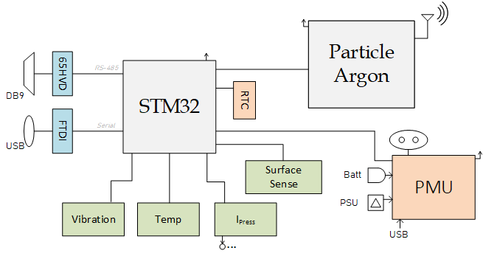

**Figure 5:** Xtag Schematic Illustration

**Control**: SM32F09, Particle Argon

**System**: PMU, RTC, SD, Flash

**Comm**: RS-4857, Modbus8

**Radio**: Wi-Fi, BLE

**Sense**: Thermal, Pressure, Vibration, Acceleration

**Reference**: Pump VFD

## Goals

* Design is ready for manufacture
* Pump & bearing frame monitor with report
* Warning & notification for safety and optimization

## Xtag-POC Module Solution

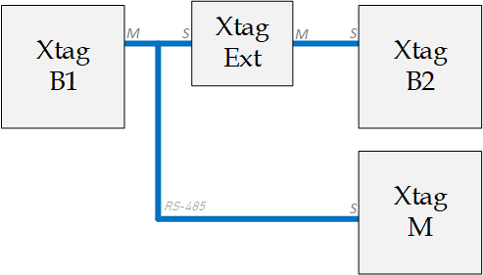

**Figure 6:** Module Communications Architecture

Xtag modules use RS-485 for module communications and follow the architecture displayed in Figure 6.

Notes:

1. The Xtag-Ext is transparent to Xtag-POC operations and can be removed at any time
2. Xtag-Board includes the Particle Argon, enabling module communication over Bluetooth-Mesh as an alternative to RS-485

## Xtag-B2

**Control**: SM32F09

**Interface:** 65HVD

**Comm**: RS-485

**Sense**: Thermal, Vibration,

Acceleration

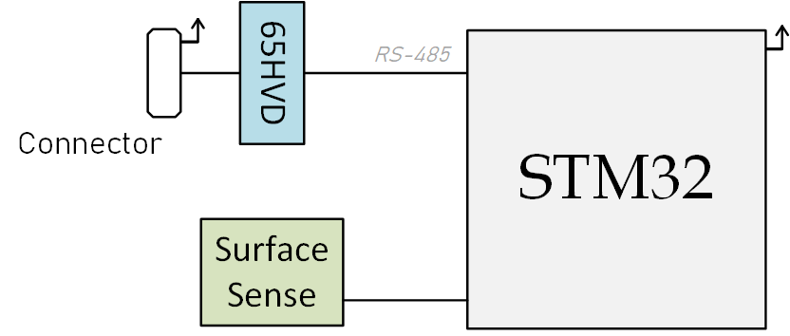

**Figure 7:** Xtag-B2 Schematic Illustration

## Xtag-M

**Control**: SM32F09

**Interface:** 65HVD

**Comm**: RS-485

**Sense**: Thermal, Vibration,

Acceleration, Motor Flux

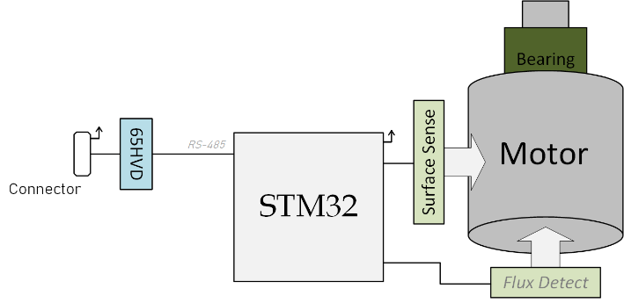

**Figure 8:** Xtag-M Schematic Illustration

## 

## Xtag-Ext

**Control**: SM32F09

**Interface:** 65HVD (Xtag-B1: Master,

Xtag-B217: Follower)

**Comm**: RS-485

**Memory:** SD Card, Local Flash

**Click**: LAN, USB & RS-485 options

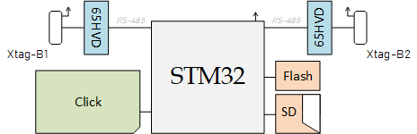

**Figure 9:** Xtag-Ext Schematic Illustration

## Level Description

The following levels are requested for development, all provided with the Xtag-PoC. See Table 4***:*** Xtag Feature Specification for graphical illustration of all levels.

Level 1 - Local monitoring of the pump running condition, powered by battery or external supply

Level 2 - Level 1 with duty point monitoring, analysis, report & recommendations for improvement. VFD reference provision included.

Level 3 - Level 2 with completed Xtag specification (see [1])

## Design Modularization

The Xtag PoC will be a single board designed to test a broad range of modularization options. For example, the Xtag PoC may be placed on the bearing frame and employ embedded vibration and temperature sensors while collecting data from remote sensors attached by wires or embedded sensors in another Xtag mounted to the pump or motor housings.

## System Integration

Xtag is mounted to the bearing frame for Levels 1 & 2, featuring onboard bearing sensing when available.

## Design Flow

Ergsense will generate the proof of concept covering all functionality of Levels 1, 2 & 3 and share with Xylem for review and iterate the design until desired results are achieved.

## Device Validation

Demonstrate and document functionality on a three phase 230V 3HP or smaller motor driven by a VFD.

Deliver full test report and documentation package.

1. Firmware (FW) & Software (SW) source code
2. Schematics and PCB layout in Eagle CAD format (Use Altium tool for final PCB design)
3. Enclosure mechanical design and 3D CAD / CAM files in ProE format
4. Costed BoM with volume model applied to 10k pieces
5. Test report and any supporting documentation not covered elsewhere
6. Supply chain suggestions (includes sources of supply, qualification & assembly

Testing validation

1. Internal (Ergsense LLC, Olympia, WA)
2. External (Xylem, Morton Grove, IL)

## Deliverables

The Xtag PoC will be delivered in a series of three progressive deliverables, incrementally advancing towards the final PoC result. The deliverables will follow the agreed upon SoW.

1. Gate 1 Delivery of xTAG conceptual architecture document
2. Gate 2 Initial test report and project review completed
3. Gate 3 Delivery of prototypes, documentation and final review

# Device Design



## Hardware Design Procedure

Ergsense shall design all HW for the Xtag-PoC using best practices for maintaining a professional product. This includes:

1. Defined design flow
2. Structured and maintained design repository (includes FW repos as well)
3. Managed library of components (footprints, devices and symbols)

## POC Components

Select components are not intended for Xtag product, presented here –

* Xtag-B1 Button (SW2) & LED (LED2)
* SD Card Adapter (X3)
* Click Adapter (J7)
* Flash IC (U15)

## Technology Selection

* STM STM32F091CCn7 Series for control
  + STM32F091RC for PoC (Dev Board & Ref Support)
  + See Appendix A for selection procedure
* Particle Argon
  + Wi-Fi & BLE Support
  + Multi-radio support with clean reference & high reliability
* ST LIS3DH for acceleration
  + Popular, Low-cost solution with wide feature set

## Design Selection Opens

* Flow-rate sensor integration

# Next Steps

PoC Next Steps

1. Xylem approval of this working document and decision to proceed
2. Generation of schematics for review
3. Electrical design review

# Appendix A – Processor Selection

The following procedure was used for processor selection, listed in order. The selection meets with expected Xtag product needs, and is expected to adjust slightly over time (e.g. memory size or pin count). The current selection is listed below, with explanation for each choice.

1. **Family Selection:** ST STM32 (Features, Power, Cost)
2. **Line Selection:** F-Series (Mainstream)
3. **Architecture:** F0 (Cortex M0, Cost)
4. **Family** 9 (FLASH, RAM18)
5. **Product Line** 1 (Access Line19, entry point to STM32)
6. **Pin Count:** R (64-pin)
7. **Memory:** C (256 Kbyte User Memory Space)
8. **Package:** T (LQFP, nice blend of form factor and cost)
9. **Range:** 7 (-40 to 105 °C)
10. **Unit:** F091RCT7 (IO, Temperature)

Comparison of Units

Following steps 1-5 a comparison selection of families is observed, with Mouser prices in 10kU volumes –



**Table 6:** Processor selection comparison

**Selection:** STM32F091RCT7 ($2.40/10kU)

# Definitions

Table 7 presents the vocabulary definitions used in this document.



**Table 7:** Vocabulary Glossary

# Acronyms

Table 8 presents the acronyms used in this document.



VFD Variable Frequency Drive

XB Xtag Board

**Table 8:** Acronyms Glossary (note: Office bug restricting table edits)

# References

1. Initial Spec (8/2/18)
2. Justin Review of Spec (8/3/18)
3. Commercial Specification for Pump Monitoring System v3.11 (8/8/18)
4. Xylem EDGE Intelligence Concept requirements (8/6/18)
5. XY.0 STAGE 1 – Xtag, CONNECTED EAM v1.0 (11/17)
6. Xylem email - flux sensing (8/9/18)
7. Xtag Architecture (8/10/18)
8. [STM32 32-bit ARM Cortex MCU's](https://www.google.com/url?sa=t&rct=j&q=&esrc=s&source=web&cd=2&ved=2ahUKEwi0o8mgyOHcAhWJyIMKHS1dDycQFjABegQICRAC&url=https%3A%2F%2Fwww.st.com%2Fresource%2Fen%2Fbrochure%2Fbrstm32.pdf&usg=AOvVaw3xXouFLeuOisZAO4q1bh97) ([ref](https://www.st.com/content/ccc/fragment/product_related/class_information/class_level_diagram/group0/1b/96/39/54/20/23/46/bf/stm32_cl1734/files/stm32_cl1734.jpg/_jcr_content/translations/en.stm32_cl1734.jpg))

# 

# Notes

1. Including RTU, HMI & others
2. Timing for sample rate requirements and user interface response as identified by customer
3. IP54 may be selected at the product integration stage
4. 10kU price for Ergsense’s Level 1 PoC, excluding consideration of L2, L3 and all external peripherals
5. For PoC only
6. Buffering size to be established on PoC completion
7. Wired ethernet support is considered via LAN, supported by STM32 family
8. Min, Max, Std, Avg, Mean, Kurtosis & Quantity
9. Desired but not specified at this time
10. Feature to be integrated post PoC generation
11. Based upon Xylem supplied pump performance data
12. Amazon AWS is a placeholder for xCloud features and support, with most targeted functionality & features provided. MQTT, JSON prospect for future support
13. The Xtag-B2 second bearing module is an optional module at this time
14. Communication gateways commonly support RS-485 if needed
15. Modbus-slave support to RTU is provided over the RS-485 interface
16. Xerafy is identified for RFID integration
17. Device is inline and module selection can be handled at runtime (e.g. Xtag-B2 or Xtag-M)
18. This question is currently under resolution with STM support
19. The Access line is the entry point of the STM32 family, providing a high integration of functions with the power of a 32-bit MCU but at a 16-bit MCU cost. Its peripheral set offers excellent connectivity and control
20. Review the Seeed architecture here - [Seeed Grove Introduction](http://wiki.seeedstudio.com/Grove/)